|  |  |
| --- | --- |
| Date | 21 october2022 |
| Student Name | Gayatri padma sree |
| Student Register Number | 211419106086 |
| Maximum Marks | 2 marks |

WOKWI WEB URI:

<https://wokwi.com/projects/322410731508073042>

SNAPSHOTS OF SIMULATION:

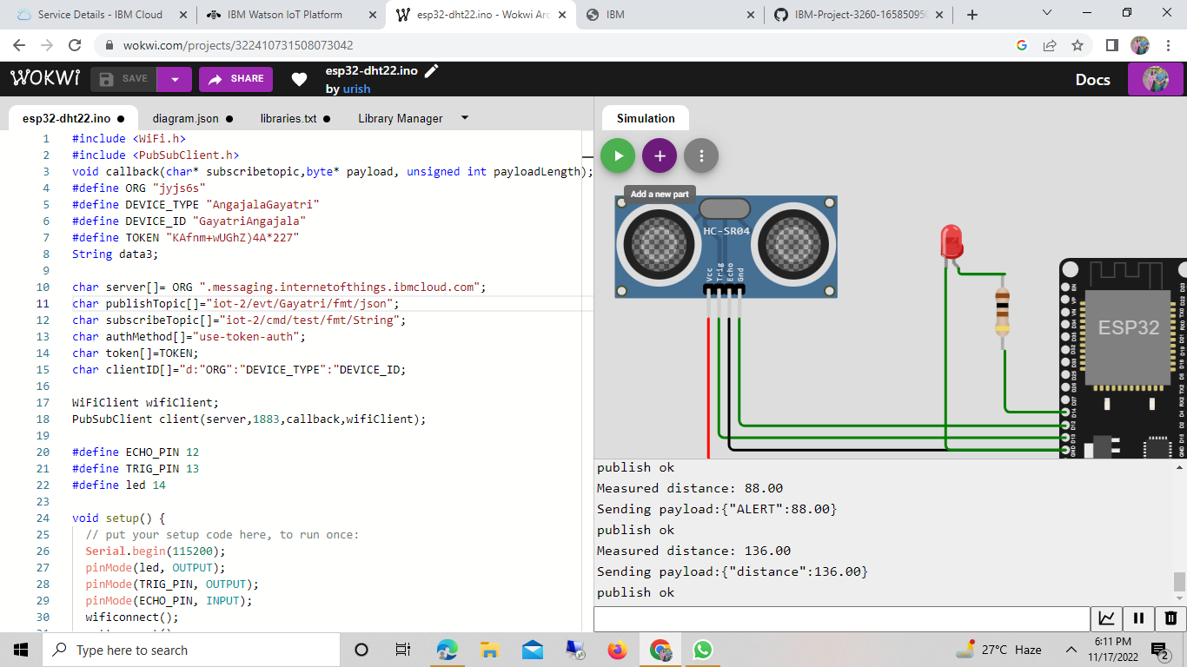

Name:gayatri padma sree reg.no:211419106086

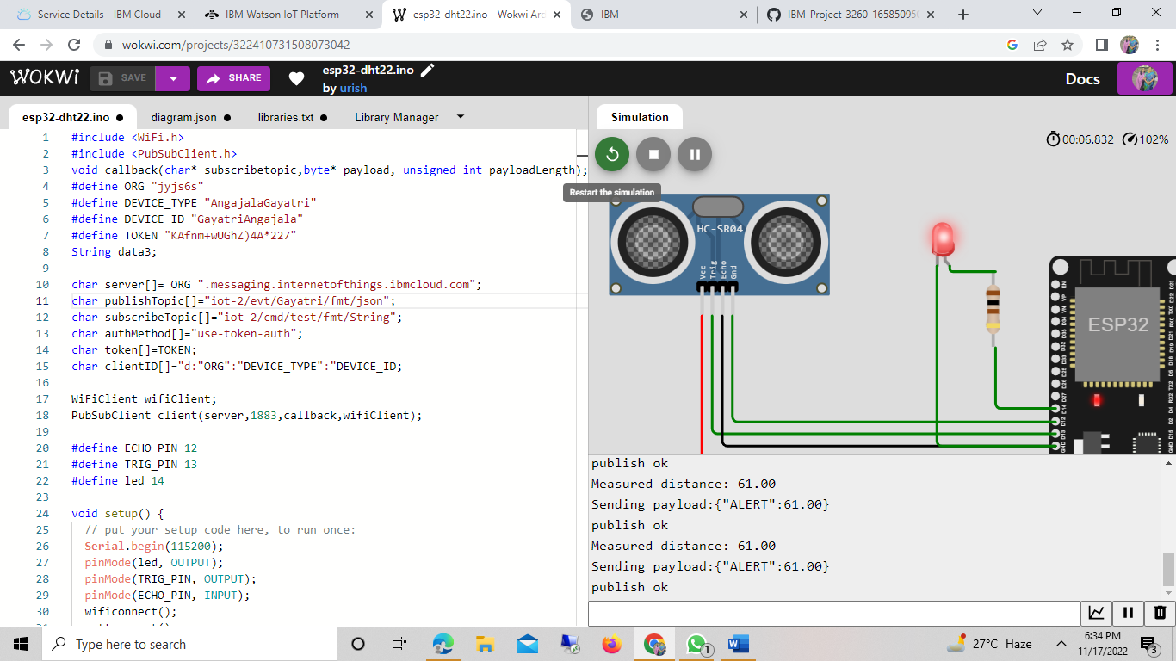

IMAGE OF IBM CLOUD: